SIMATS ENGINEERING
ASSESSMENT TOOL 1

COURSE NAME: Artificial Intelligence COURSE CODE: CSA1715

COURSE OUTCOME COVERED
CO1: Apply AI basics such as intelligent agents and uninformed search methods to
solve problems effectively. (BL3)
Assessment Tool Weightage: 40%

QUESTIONS: 5 Duration : 1 Hour
Total Marks:50
Annexure A
Analytical Problem Solving

Code of Conduct:
I SAISHRUTHIKA M(192572154 (Name / Reg No) certify that this submission is my original work and that I have adhered to the guidelines specified for this assessment.I understand that any violation of academic integrity rules will result in disciplinary action.
Signature of the student:
SAISHRUTHIKA M

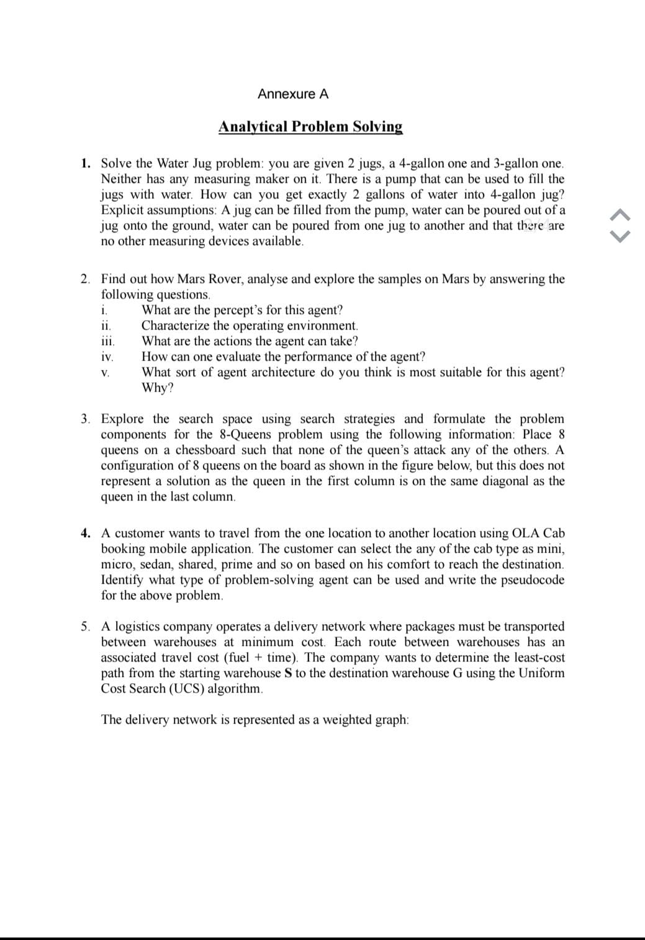

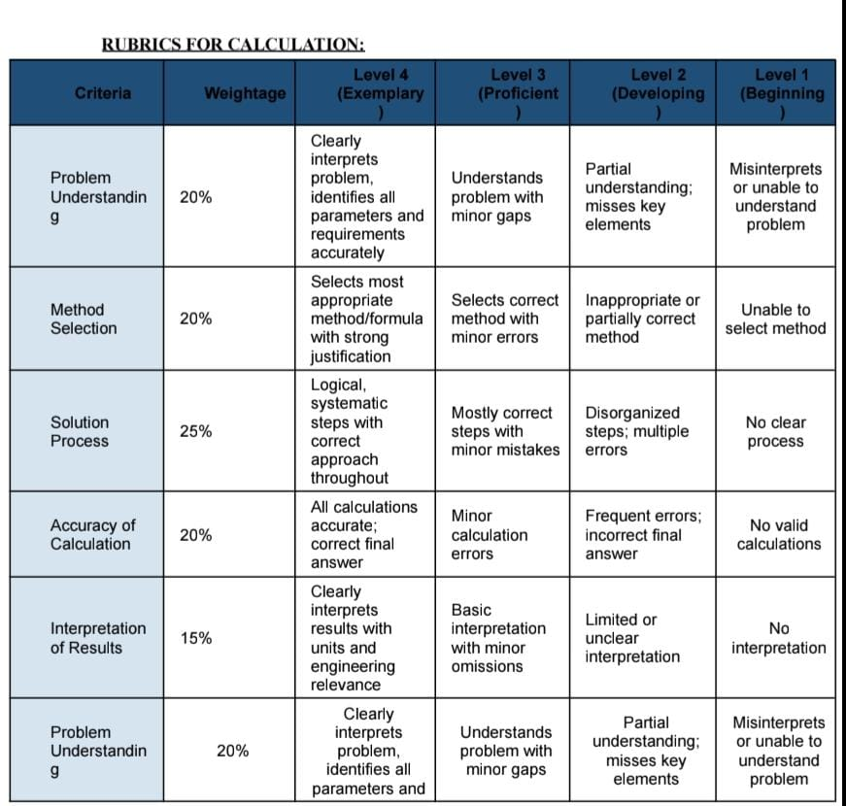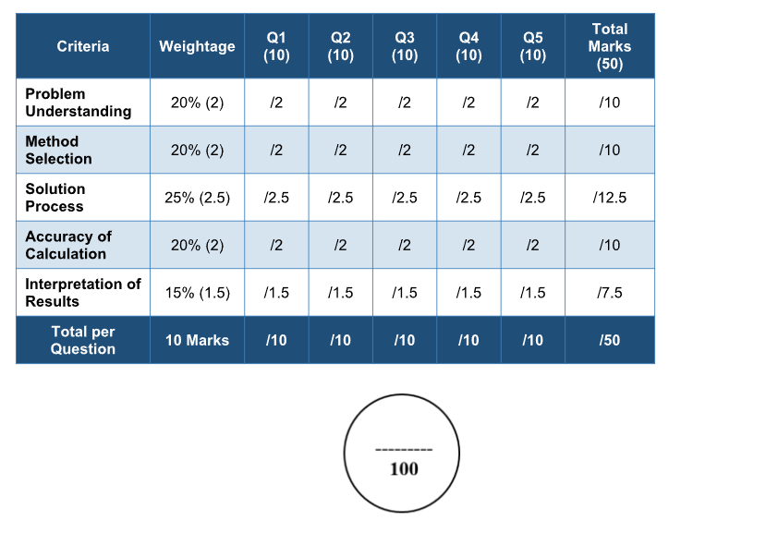
Analytical Problem Solving

1.Problem:
Two jugs are available:
- Jug A = 4 gallons
- Jug B = 3 gallons
There are no measuring marks on the jugs. Water can be filled from a pump, emptied onto the ground, or poured from one jug to another.
Goal: Obtain exactly 2 gallons of water in the 4-gallon jug.

Solution
Initial State: (0,0)
Step | Action | State (4G,3G)
1 | Fill the 3-gallon jug | (0,3)
2 | Pour water from the 3G jug into the 4G jug | (3,0)
3 | Fill the 3-gallon jug again | (3,3)
4 | Pour water into the 4G jug until it is full | (4,2)
5 | Empty the 4-gallon jug | (0,2)
6 | Pour the remaining 2 gallons from the 3G jug into the 4G jug | (2,0)
State Space Diagram
(0,0)
│ Fill 3G
▼
(0,3)
│ Pour to 4G
▼
(3,0)
│ Fill 3G
▼
(3,3)
│ Pour to 4G
▼
(4,2)
│ Empty 4G
▼
(0,2)
│ Pour to 4G
▼
(2,0) ← Goal State
Therefore, exactly 2 gallons of water are obtained in the 4-gallon jug.
Goal State: (2,0)

Pseudo Code – Water Jug Problem (4-Gallon & 3-Gallon Jugs)
Algorithm: Water_Jug_Problem
Start
1. Fill the 3-gallon jug.
2. Pour the 3-gallon jug into the 4-gallon jug.
3. Fill the 3-gallon jug again.
4. Pour water from the 3-gallon jug into the 4-gallon jug
until the 4-gallon jug is full.
5. Empty the 4-gallon jug.
6. Pour the remaining 2 gallons from the 3-gallon jug
into the 4-gallon jug.
7. Stop when the 4-gallon jug contains exactly 2 gallons.
End
Output
4-gallon jug = 2 gallons
3-gallon jug = 0 gallons.

2. Mars Rover
I. What are the precepts for this agent?
Percept’s are the information collected by the Mars Rover through its sensors.
- Camera images of the Martian surface
- Rock and soil composition
- Temperature
- Atmospheric pressure
- Humidity and weather conditions
- Obstacle and terrain information
- Radiation levels
- GPS/position and navigation data
ii. Characterize the operating environment
The Mars Rover operates in the following environment:
- Partially Observable – The rover cannot observe the entire environment at once.
- Deterministic – The result of most actions is predictable.
- Sequential – Current actions affect future actions.
- Dynamic – Weather, dust storms, and terrain may change.
- Continuous – Movement and sensing occur continuously.
- Single Agent – The rover performs its tasks independently.

iii. What are the actions the agent can take?
- Move forward, backward, left, and right
- Avoid obstacles
- Capture images and videos
- Collect rock and soil samples
- Analyse samples using onboard instruments
- Drill rocks
- Send collected data to Earth
- Monitor environmental conditions
iv. How can one evaluate the performance of the agent?
The Mars Rover's performance is evaluated based on:
- Accuracy of sample collection
- Quality of scientific data collected
- Successful navigation without collisions
- Completion of assigned missions
- Efficient use of battery power
v. What sort of agent architecture is most suitable for this agent? Why?
Goal-Based Agent with Learning Capability
Reason:
- It works towards achieving mission goals such as exploring Mars and collecting samples.
- It makes decisions based on the current environment.
- It can learn from previous observations and improve future navigation and exploration.
- It adapts to unexpected obstacles and changing environmental conditions.

Conclusion
The Mars Rover is an intelligent autonomous agent that uses sensors to perceive the Martian environment, makes decisions using AI, collects and analyses samples, and sends valuable scientific information back to Earth. This makes a Goal-Based Learning Agent the most suitable architecture.

3. Problem Statement
The 8-Queens problem is to place 8 queens on an 8 × 8 chessboard such that no two queens attack each other. This means:
- No two queens should be in the same row.
- No two queens should be in the same column.
- No two queens should be on the same diagonal.
Problem Components
1. Initial State
- An empty 8 × 8 chessboard with no queens placed.
2. State Space
- All possible arrangements of queens on the chessboard.
- Each state represents a partial or complete placement of queens.
3. Actions (Operators)
- Place a queen in a safe position on the next column.
- Move to the next column after placing a queen.
- If no safe position is available, backtrack and try another position.
4. Goal State
A valid arrangement where:
- All 8 queens are placed.
- No two queens attack each other.
5. Path Cost
- Each queen placement has a cost of 1.
- Total cost to reach the goal = 8 placements.
Search Strategy
The Backtracking Search Algorithm (Depth-First Search) is commonly used.
Steps
- Start with an empty chessboard.
- Place the first queen in the first column.
- Move to the next column and place another queen in a safe row.
- Continue until all 8 queens are placed.
- If no safe position exists, backtrack to the previous queen and try another position.
- Repeat until a valid solution is found.
State Space Representation
Initial State
↓
Place Queen in Column 1
↓
Check Safe Position
↓
Place Queen in Column 2
↓
...
↓
Place Queen in Column 8
↓
Goal State (8 Queens placed safely)
Performance Measure
- All 8 queens are placed successfully.
- No two queens attack each other.
- Minimum number of backtracking steps.
Agent Type
Goal-Based Agent
Reason:
The agent continuously searches for a configuration that satisfies the goal of placing all 8 queens safely. It uses backtracking to explore the search space until the goal state is reached.
Conclusion
The 8-Queens problem is a state-space search problem solved efficiently using Depth-First Search (DFS) with Backtracking. The algorithm systematically explores possible queen placements and backtracks whenever a conflict occurs, eventually finding a valid solution where no two queens attack each other.

4.OLA Cab Booking
Type of Problem-Solving Agent
The Goal-Based Agent is used in the OLA Cab booking application.
Reason:
The customer has a goal of reaching the destination. The agent evaluates different cab options (Mini, Micro, Sedan, Shared, Prime, etc.) and selects the most suitable cab to achieve the goal based on comfort, cost, and availability.
PEAS Description
- Performance Measure: Reach destination safely, quickly, and economically.
- Environment: Roads, traffic, GPS location, available cabs, destination.
- Actuators: Book cab, select cab type, confirm ride, cancel ride.
- Sensors: GPS, user location, destination input, fare details, cab availability.
Pseudocode
Algorithm OLA_Cab_Booking
Start
1. Enter current location.
2. Enter destination.
3. Display available cab types:
Mini, Micro, Sedan, Shared, Prime.
4. User selects a preferred cab type.
5. Check whether the selected cab is available.
6. If available then
Calculate fare and estimated arrival time.
Confirm booking.
Assign driver and start the trip.
Else
Display "Selected cab not available".
Ask the user to choose another cab.
7. Reach the destination.
8. End the trip and calculate final fare.
Stop
Conclusion
Thus, the Goal-Based Problem Solving Agent is suitable for the OLA Cab booking system because it chooses actions that help the customer achieve the goal of reaching the destination efficiently and comfortably.

5. Uniform Cost Search (UCS) for Logistics Delivery Network
Problem Statement
A logistics company needs to transport a package from the starting warehouse (S) to the destination warehouse (G). Each road connecting two warehouses has a travel cost, which includes fuel consumption and travel time. The objective is to determine the least-cost path using the Uniform Cost Search (UCS) algorithm.
Problem Formulation
Initial State
- Starting warehouse S.
Goal State
- Destination warehouse G.
State Space
- All warehouses connected through different delivery routes.
Actions
The delivery vehicle can:
- Move from one warehouse to another.
- Choose any connected route.
- Continue until the destination is reached.
Transition Model
Moving from one warehouse to another adds the travel cost of that route.
Path Cost
The total cost is calculated as:
Path Cost = Fuel Cost + Travel Time Cost
The objective is to minimize the total travel cost.
Search Strategy
The Uniform Cost Search (UCS) algorithm expands the node having the lowest cumulative cost first. Unlike Breadth-First Search, UCS considers edge costs instead of only the number of steps. It guarantees the optimal solution when all path costs are positive.
Algorithm: Uniform Cost Search
Performance Evaluation
The efficiency of UCS is measured by
- Finding the minimum travel cost.
- Selecting the shortest economical route.
- Reducing fuel consumption.
- Reducing delivery time.
- Successfully reaching the destination.
- Avoiding unnecessary path exploration.
Conclusion
Uniform Cost Search is the most suitable algorithm for logistics route planning because it always selects the warehouse with the lowest cumulative travel cost. By expanding the cheapest path first, it guarantees that the package reaches the destination using the minimum possible transportation cost, making it ideal for real-world delivery networks.

